**1 INTRODUCTION**

**Samsung** is a South Korean [multinational](https://en.wikipedia.org/wiki/Multinational_corporation) [conglomerate](https://en.wikipedia.org/wiki/Conglomerate_(company)) headquartered in [Samsung Town](https://en.wikipedia.org/wiki/Samsung_Town), [Seoul](https://en.wikipedia.org/wiki/Seoul). It comprises numerous affiliated businesses, most of them united under the Samsung brand, and is the largest South Korean business Company.

**Lenovo Group Limited** often shortened to **Lenovo**, is a Chinese [multinational](https://en.wikipedia.org/wiki/Multinational_corporation) technology company with headquarters in [Beijing](https://en.wikipedia.org/wiki/Beijing). It designs, develops, manufactures, and sells [personal computers](https://en.wikipedia.org/wiki/Personal_computer), [tablet computers](https://en.wikipedia.org/wiki/Tablet_computer), [smart phones](https://en.wikipedia.org/wiki/Lenovo_smartphones), [workstations](https://en.wikipedia.org/wiki/Workstation), [servers](https://en.wikipedia.org/wiki/Server_(computing)), [electronic storage](https://en.wikipedia.org/wiki/Electronic_storage) devices, IT management software, and [smart televisions](https://en.wikipedia.org/wiki/Smart_TV).

* 1. **SAMSUNG J8**

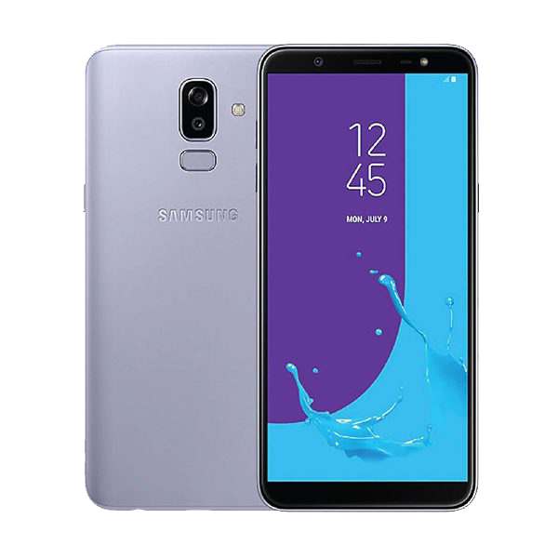

The Samsung Galaxy J8 is an [Android](https://en.wikipedia.org/wiki/Android_(operating_system)) [Smartphone](https://en.wikipedia.org/wiki/Smartphone) developed by the [Korean](https://en.wikipedia.org/wiki/South_Korea) manufacturer [Samsung Electronics](https://en.wikipedia.org/wiki/Samsung_Electronics). Announced on May 22, 2018 and released the same day along with the [Galaxy J6](https://en.wikipedia.org/wiki/Samsung_Galaxy_J6) and the [Galaxy J4](https://en.wikipedia.org/wiki/Samsung_Galaxy_J4), the J8 is a mid-range model Smartphone and a successor to the [Galaxy J7](https://en.wikipedia.org/wiki/Samsung_Galaxy_J7_(2017)). It has a similar hardware design and software features to its high-end counterpart with a [fingerprint](https://en.wikipedia.org/wiki/Fingerprint) sensor. The [Samsung Galaxy J8](http://samsungstore.pk/product/samsung-galaxy-j8-4g-64gb/) is like a refined version of the hardware design introduced in the [Samsung Galaxy J6](https://en.wikipedia.org/wiki/Samsung_Galaxy_J6), it has a rounded polycarbonate chassis. The [Galaxy J8'](https://en.wikipedia.org/wiki/Samsung_Galaxy_J_series)s display is larger than other phones in the same series launched in 2018, with a 6.0 inches (~66.3% screen-to-body ratio), 1480 pixels, 18.5:9 ratio (~293 [ppi](https://en.wikipedia.org/wiki/Pixels_per_inch) density) Super [AMOLED](https://en.wikipedia.org/wiki/AMOLED) screen, and Corning Gorilla Glass.

**Snapdragon SDM450Processor:**

The Qualcomm® Snapdragon™ 450 mobile platform uses leading-edge 14 nm technology to power premium experiences in high-tier smartphones without draining the battery. With features like support for real time Bokeh camera effects, an integrated Qualcomm® Snapdragon™ X9 LTE modem, and Qualcomm® Adreno™ 506 PC-class graphics, the Snapdragon 450 is designed to provide fast connectivity, vibrant displays, and performance that's both powerful and efficient.

CPU Clock Speed: Up to 1.8 GHz

CPU Cores: 8x ARM Cortex A53, Octa-core CPU

CPU Architecture: 64-bit

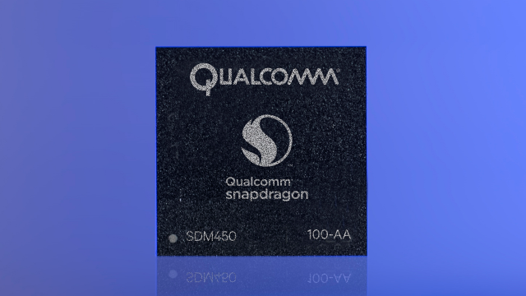

**Graphics Processing Unit:**

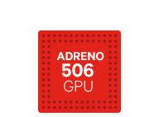

An integrated Adreno 506 GPU delivers processing power for dazzling displays, enabling up to 25% faster graphics rendering and 30% lower power when compared to the Snapdragon 435.

**Camera:**

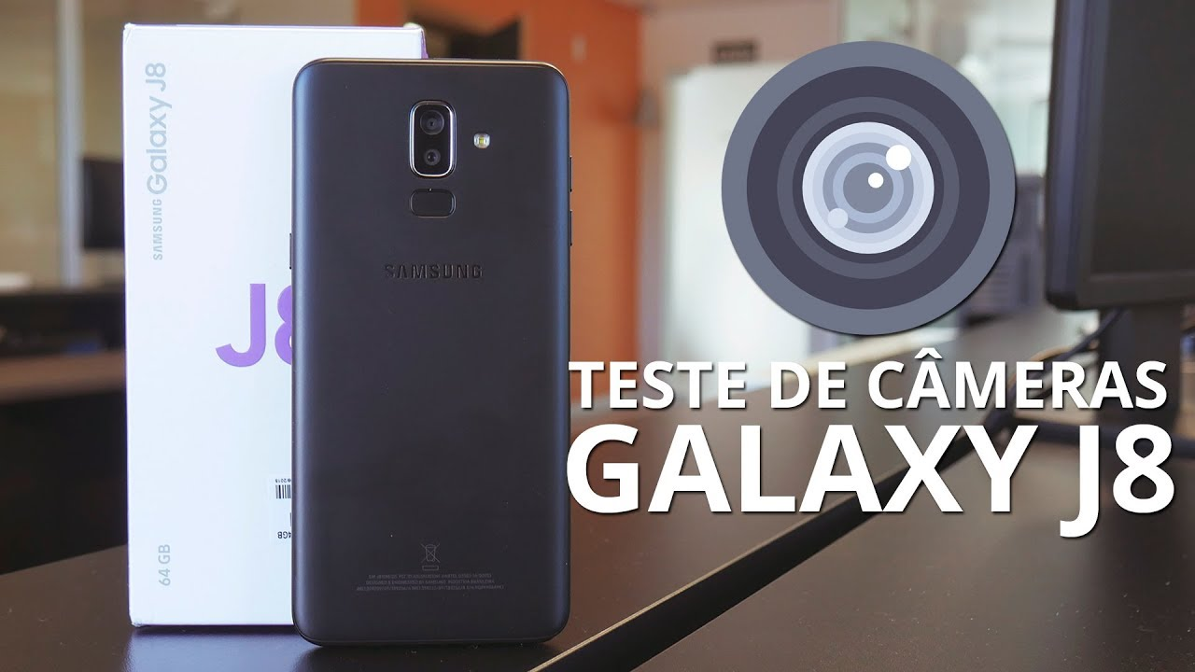

The Samsung Galaxy J8 ships with 16+5 MP Dual rear camera with Auto focus and 4x Digital zoom and a 16-megapixel front-facing camera with F1.9 LED flash.  The dual-camera setup allows the Galaxy J8 to capture images with background blur (also known as portrait images).

**Battery:**

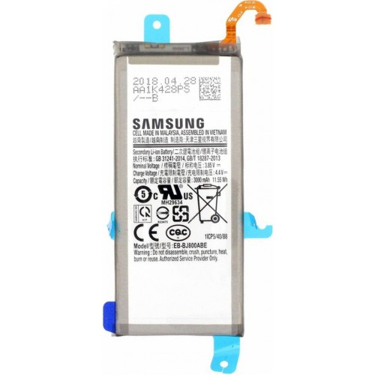

Devices require less frequent charging thanks to a low-power Cortex A53 processor and efficiency-boosting features like universal bandwidth compression. The Samsung Galaxy J8 is fueled by a 3,500mAh battery.

**Storage:**

The smartphone is bundled with an onboard storage of 64GB which one can expand further using a microSD card up to 256GB. The Galaxy J8 comes with an octa-core Snapdragon 450 chipset which is coupled with [4GB of RAM](https://www.mysmartprice.com/mobile/pricelist/samsung-4gb-ram-mobiles-in-india.html).

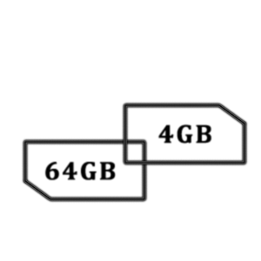

**Android v8.0 (Oreo)**

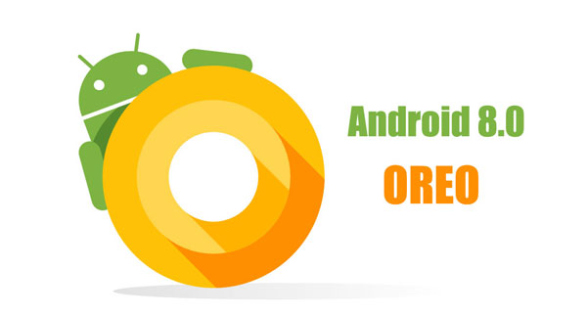

It contains a number of major features, including notification grouping, [picture-in-picture](https://en.wikipedia.org/wiki/Picture-in-picture) support for video, performance improvements and battery usage optimization, and support for [auto fillers](https://en.wikipedia.org/wiki/Autofill), [Bluetooth 5](https://en.wikipedia.org/wiki/Bluetooth_5), system-level integration with [VoIP](https://en.wikipedia.org/wiki/VoIP) apps, wide [color gamuts](https://en.wikipedia.org/wiki/Color_gamut), and [Wi-Fi Aware](https://en.wikipedia.org/wiki/Wi-Fi_Aware).

**Display:**

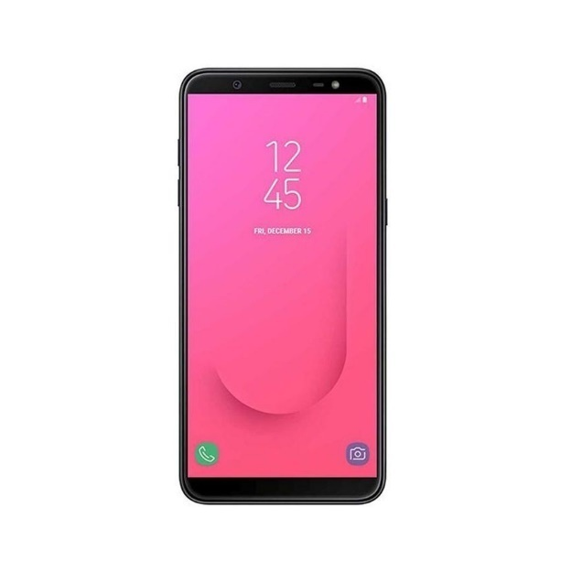

The handset has a 6-inch HD+ display. The display uses Super AMOLED technology and it has a bezel-less design. The resolution of display is 720x1480 pixels. And the Aspect Ratio is 18.5:9. It has 274 pixels per inch (ppi). Samsung galaxy j8 has Capacitive touchscreen.

* 1. **LENOVO K4 NOTE:**

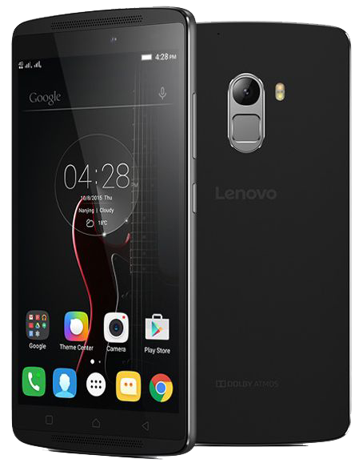

Lenovo K4 Note is a midrange [Android](https://en.wikipedia.org/wiki/Android_(operating_system)) smartphone launched by [Lenovo Group Limited](https://en.wikipedia.org/wiki/Lenovo_Group_Limited) in January 2016. The phone features a 5.5 inch [FHD](https://en.wikipedia.org/wiki/FHD) display powered by Corning [gorilla glass 3](https://en.wikipedia.org/wiki/Gorilla_Glass). It comes with two storage variants of 16 and 32 [GB](https://en.wikipedia.org/wiki/Gigabyte) with 2 GB of [RAM](https://en.wikipedia.org/wiki/Random_Access_Memory), for A7010 model and 3 GB of RAM for A7010a48 model. The device supports Theater max technology with a [VR](https://en.wikipedia.org/wiki/Virtual_reality) headset. Upon its release in the market, it received positive feedbacks and reviews from all parts of the world. Lenovo also launched its successor, K5 Note immediately after K4 Note's launch.

**Mediatek MT6753Processor:**

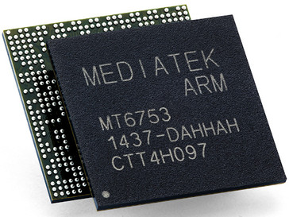

MediaTek MT6753 is a 64-bit octa-core WorldMode 4G LTE® platform based on the ARM® Cortex® -A53 64-bit processor with ARM Mali™ -T720 graphics. Designed for the super-mid market, MT6753 delivers a premium mobile experience and gives consumers a wider choice of smart devices at more affordable prices. MT6753 features integrated WorldMode 4G LTE and CDMA2000® 3G for global high-speed mobile network compatibility.

Dual-band 802.11n Wi-Fi® and Bluetooth® 4.0 support high-performance wireless networks and devices, and a 16-megapixel image signal-processor supports high-quality smartphone camera applications. MT6753 also supports 1080p Full HD displays, along with Full HD video recording and playback.

CPU Clock Speed: Up to 1.8 GHz

CPU Cores: 8x ARM Cortex A53, Octa-core CPU

CPU Architecture: 64-bit

**Graphics Processing Unit:**

The graphics are handled by Mali-T720MP3 GPU consisting of 3 cores for processing graphics, it is not great for heavy gaming but can handle the mid-range games pretty well.

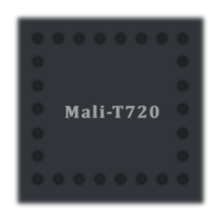

**Camera:**

The device is expected to be liked by all photography lovers as there is a stunning 13-megapixel rear-facing camera coupled with dual-tone LED flash and phase detection autofocus (PDAF). The images turn out to be vibrant and they contain good amount of details, the noise levels are kept low most of the time except in the photos taken in low-light condition. Overall the camera is not disappointing but also not the best among its competitors. The rear-facing camera can record videos upto full-HD resolution. Additional modes like HDR, panorama, face and smile detection, etc. are also present. For video calling and selfies the K4 Note ships with a 5-megapixel front-facing camera with an f/2.2 aperture.

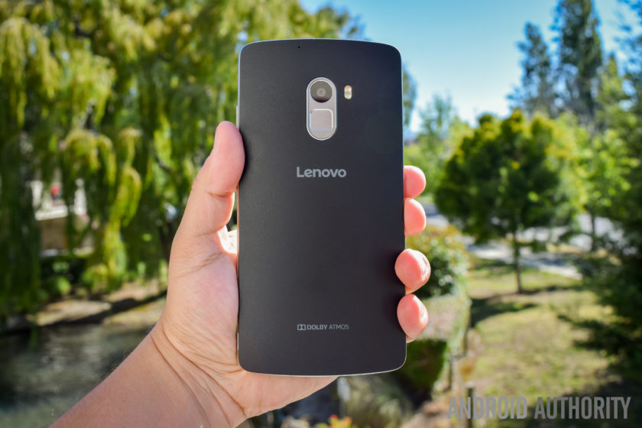

**Battery:**

The smartphone is powered by a massive 3,300 mAh battery that can keep the device up and running for more than a day on heavy usage.

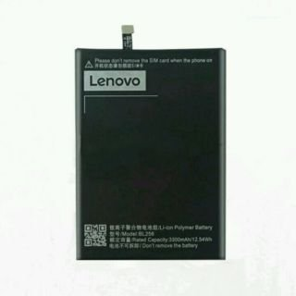

**Storage:**

The smartphone is bundled with an onboard storage of 16GB which one can expand further using a microSD card up to 128GB. The Vibe K4 Note came with a 3GB of Ram which accelerate the performance of device.

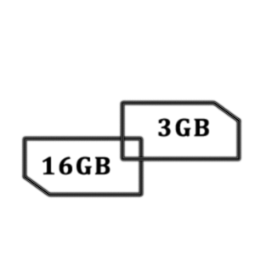

**Android v6.0 (Marshmallow)**



Marshmallow primarily focuses on improving the overall user experience of its predecessor, [Lollipop](https://en.wikipedia.org/wiki/Android_Lollipop). It introduced a new permissions architecture, new APIs for contextual [assistants](https://en.wikipedia.org/wiki/Virtual_assistant), a new power management system that reduces background activity when a device is not being physically handled, native support for [fingerprint recognition](https://en.wikipedia.org/wiki/Fingerprint_recognition) and [USB-C](https://en.wikipedia.org/wiki/USB-C) connectors, the ability to migrate data and applications to a [microSD](https://en.wikipedia.org/wiki/MicroSD) card, and other internal changes.

**Display:**

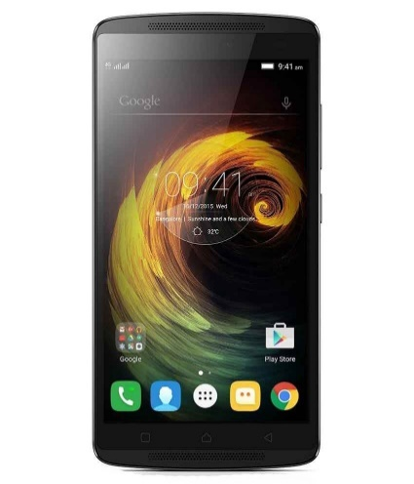

The smartphone boasts a [5.5-inch](https://www.mysmartprice.com/mobile/pricelist/5-5-inch-screen-mobiles-in-india.html) full-HD display paired with awesome viewing angles. The display reproduces vibrant images and bright colours. Also, to keep the screen scratch-free and resistant to drop, Lenovo has added Corning's Gorilla Glass 3 protection to the display.

1. **ARCHITECTURE AND FUNCTION**
   1. **Samsung Galaxy J8**

**Architecture:**

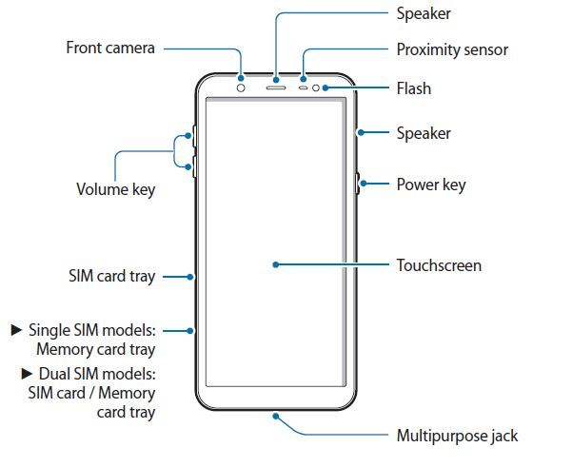

Fig No.1: Architecture of Samsung J8

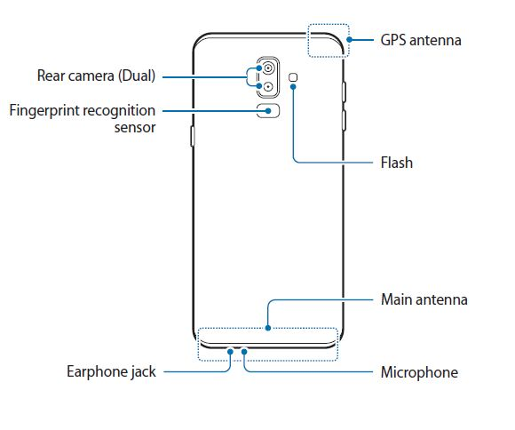

**Functions:**

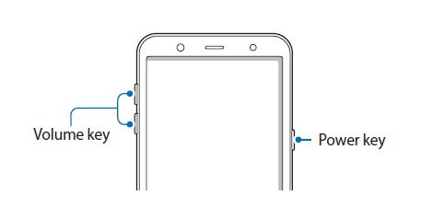

Volume key Power key

* Key Function

Power

• Press and hold to turn the device on or off.

• Press to turn on or lock the screen.

• Volume Press to adjust the device volume.

* Soft buttons

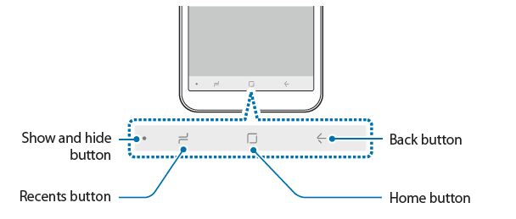

When you turn on the device, the soft buttons will appear at the bottom of the screen. The

soft buttons are set to the Recent button, Home button, and Back button by default. Refer to Navigation bar (soft buttons) for more information.

* Battery

Charging the battery

Use only Samsung-approved chargers, batteries, and cables. Unapproved chargers or cables can cause the battery to explode or damage the device. The charger should remain close to the electric socket and easily accessible while charging.

1 Connect the USB cable to the USB power adaptor

2 Plug the USB cable into the device’s multipurpose jack.

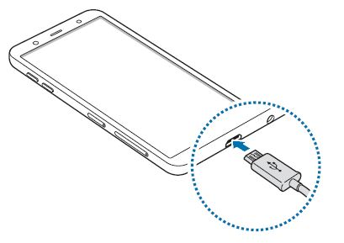

3 Plug the USB power adaptor into an electric socket.

4 After fully charging, disconnect the charger from the device. Then, unplug the charger from the electric socket.

* SIM or USIM card (Nano-SIM card)

Installing the SIM or USIM card

Insert the SIM or USIM card provided by the mobile telephone service provider.

For dual SIM models, you can insert two SIM or USIM cards so you can have two phone numbers or service providers for a single device. In some areas, data transfer speeds may be slower if two SIM cards are inserted in the device than when one SIM card is inserted.

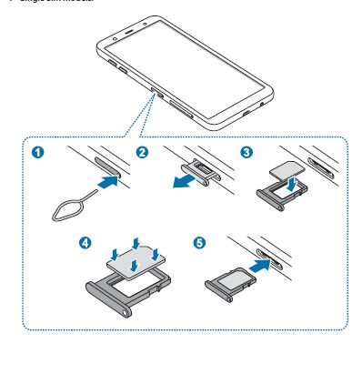

* Turning the device on and off

Press and hold the Power key for a few seconds to turn on the device.

When you turn on your device for the first time or after performing a data reset, follow the onscreen instructions to set up your device.

To turn off the device, press and hold the Power key, and then tap Power off.

Follow all posted warnings and directions from authorized personnel in areas where the use of wireless devices is restricted, such as aero planes and hospitals.

Restarting the device

If your device is frozen and unresponsive, press and hold the Power key and the Volume Down key simultaneously for more than 7 seconds to restart it.

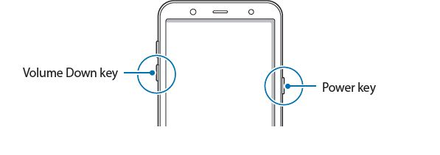

2.7 Emergency mode

You can switch the device to emergency mode to reduce battery consumption. Some apps and functions will be restricted. In emergency mode, you can make an emergency call, send your current location information to others, sound an emergency alarm, and more.

* 1. **Lenovo K4 Note**

**Architecture:**

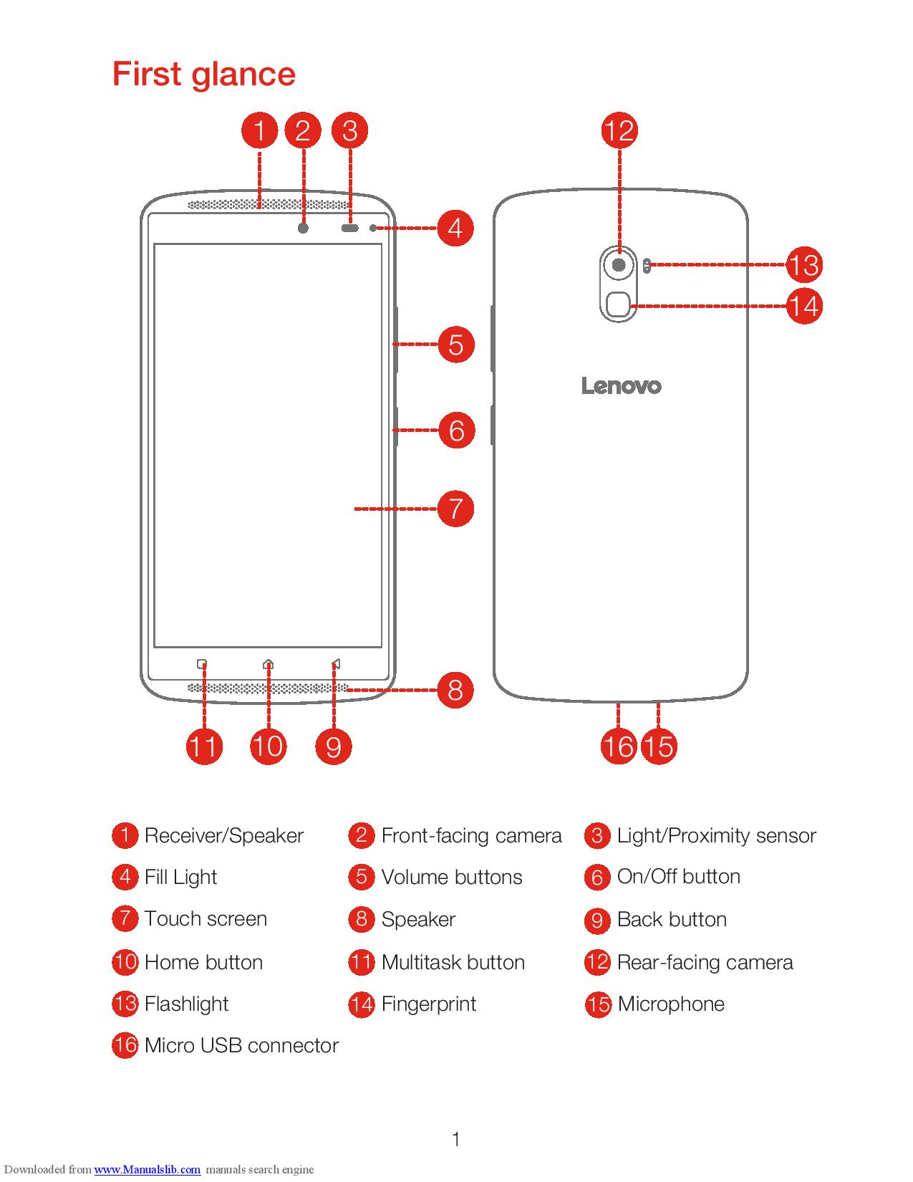

Fig No.2: Architecture of Lenovo K4 Note

**Functions:**

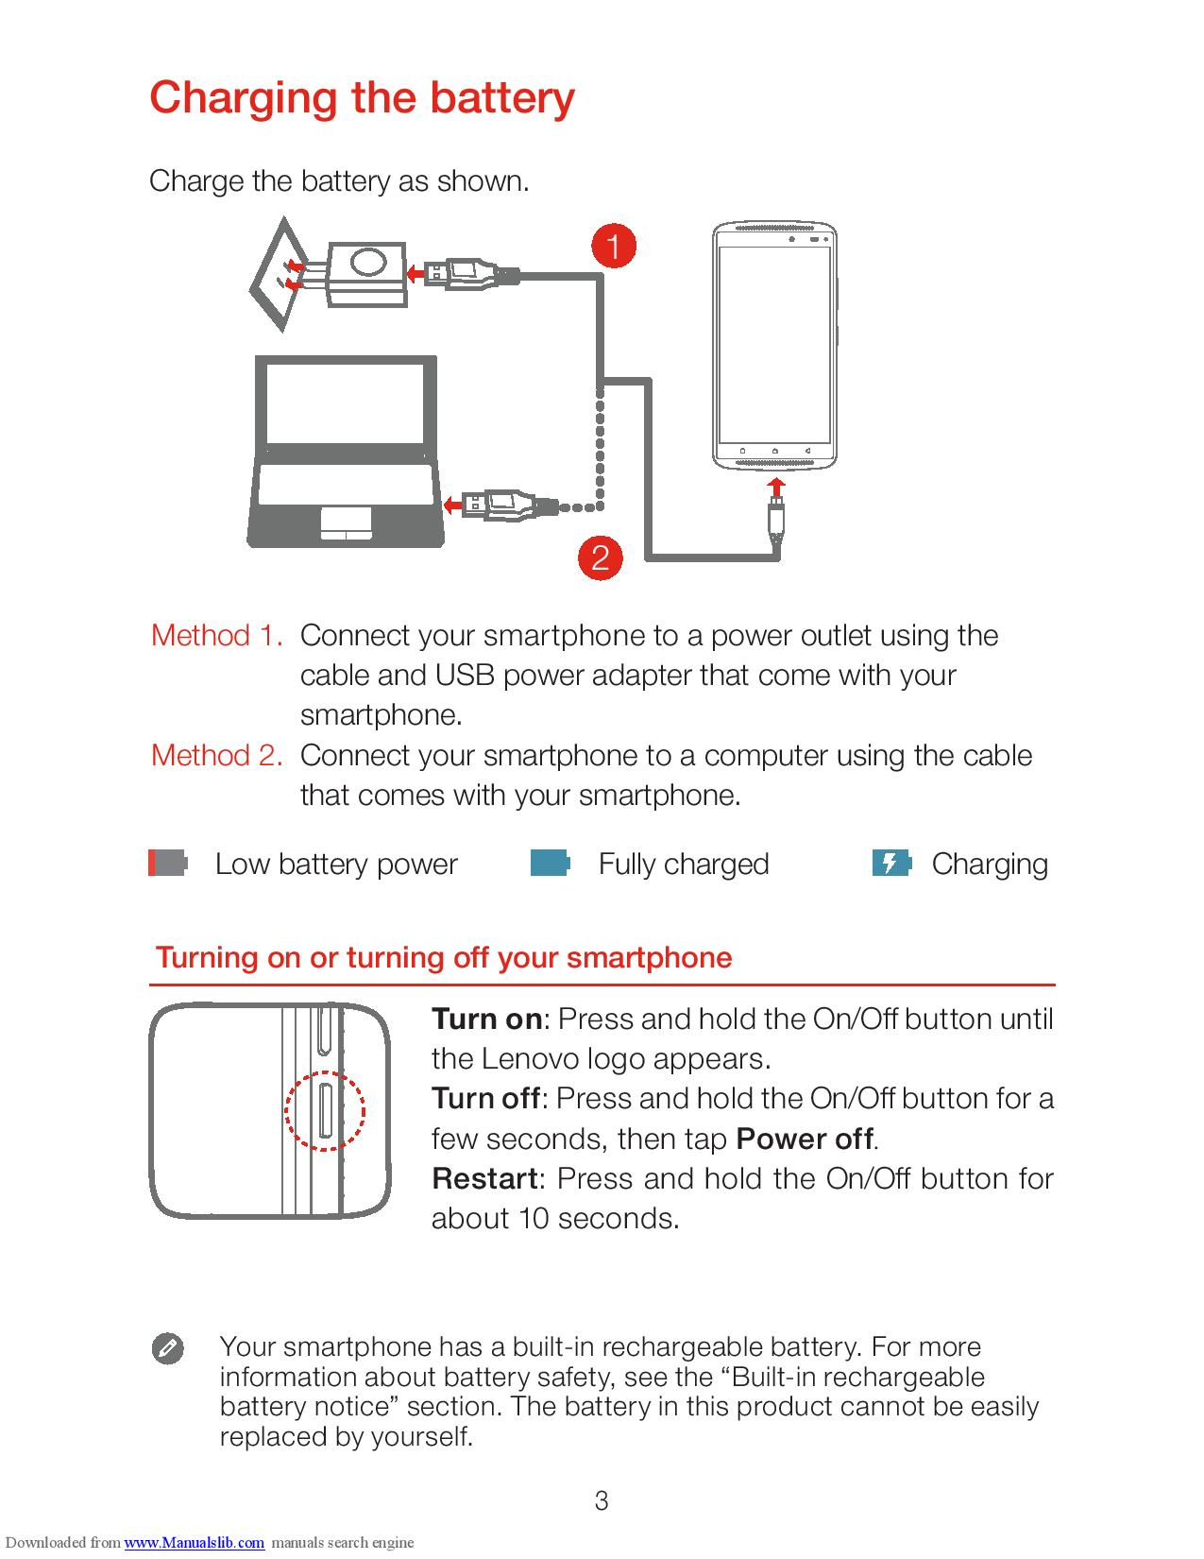

* Key Function

Turn on: Press and hold the On/Off button until the Lenovo logo appears.

Turn off: Press and hold the On/Off button for a few seconds, then tap Power off.

Restart: Press and hold the On/Off button for about 10 seconds.

* Battery

Charging the battery

Use only Samsung-approved chargers, batteries, and cables. Unapproved chargers or cables can cause the battery to explode or damage the device. The charger should remain close to the electric socket and easily accessible while charging.

Method 1. Connect your Smartphone to a power outlet using the cable and USB power adapter that come with your smartphone.

Method 2. Connect your smartphone to a computer using the cable that comes with your device.



* SIM or USIM card (nano-SIM card)

Installing the SIM or USIM card

Step 1. Open the back cover.

Step 2. Insert the Micro SIM cards into SIM1 slot and SIM2 slot.

Tip: Both of the card slots support 2G, 3G and 4G data services. When two cards are inserted at the same time, the system supports only one of them to register for 3G or 4G data service. If you want to change data service type of the card, please go to Settings > SIM management > Data connection.

Step 3. Install the back cover.

* Emergency mode

You can switch the device to emergency mode to reduce battery consumption. Some apps and functions will be restricted. In emergency mode, you can make an emergency call, send your current location information to others, sound an emergency alarm, and more.

1. **MEMORY ORGANIZATION**

The Android Runtime (ART) and Dalvik virtual machine use [paging](http://en.wikipedia.org/wiki/Paging) and [memory-mapping](http://en.wikipedia.org/wiki/Memory-mapped_files) (mapping) to manage and organize a memory. This means that any memory an app modifies whether by allocating new objects or touching mapped pages remains resident in RAM and cannot be paged out. The only way to release memory from an app is to release object references that the app holds, making the memory available to the garbage collector. That is with one exception: any files mapped in without modification, such as code, can be paged out of RAM if the system wants to use that memory elsewhere.

**Android app processes and memory allocation:**

## Garbage collection

A managed memory environment, like the ART or Dalvik virtual machine, keeps track of each memory allocation. Once it determines that a piece of memory is no longer being used by the program, it frees it back to the heap, without any intervention from the programmer. The mechanism for reclaiming unused memory within a managed memory environment is known as garbage collection. Garbage collection has two goals: find data objects in a program that cannot be accessed in the future; and reclaim the resources used by those objects.

Android’s memory heap is a generational one, meaning that there are different buckets of allocations that it tracks, based on the expected life and size of an object being allocated.Each heap generation has its own dedicated upper limit on the amount of memory that objects there can occupy. Any time a generation starts to fill up, the system executes a garbage collection event in an attempt to free up memory.

## Share memory

In order to fit everything, it needs in RAM, Android tries to share RAM pages across processes. It can do so in the following ways:

* Each app process is forked from an existing process called Zygote. The Zygote process starts when the system boots and loads common framework code and resources. To start a new app process, the system forks the Zygote process then loads and runs the app's code in the new process. This approach allows most of the RAM pages allocated for framework code and resources to be shared across all app processes.
* In many places, Android shares the same dynamic RAM across processes using explicitly allocated shared memory regions. For example, window surfaces use shared memory between the app and screen compositor, and cursor buffers use shared memory between the content provider and client.

## Allocate and reclaim app memory

The Dalvik heap is constrained to a single virtual memory range for each app process. This defines the logical heap size, which can grow as it needs to but only up to a limit that the system defines for each app.

The logical size of the heap is not the same as the amount of physical memory used by the heap. When inspecting your app's heap, Android computes a value called the Proportional Set Size (PSS), which accounts for both dirty and clean pages that are shared with other processes—but only in an amount that's proportional to how many apps share that RAM.

## Restrict app memory

To maintain a functional multi-tasking environment, Android sets a hard limit on the heap size for each app. The exact heap size limit varies between devices based on how much RAM the device has available overall. If your app has reached the heap capacity and tries to allocate more memory, it can receive an [OutOfMemoryError](https://developer.android.com/reference/java/lang/OutOfMemoryError.html).

In some cases, you might want to query the system to determine exactly how much heap space you have available on the current device—for example, to determine how much data is safe to keep in a cache. You can query the system for this figure by calling [getMemoryClass()](https://developer.android.com/reference/android/app/ActivityManager.html#getMemoryClass()). This method returns an integer indicating the number of megabytes available for your app's heap.

## Switch apps

When users switch between apps, Android keeps apps that are not foreground—that is, not visible to the user or running a foreground service like music playback— in a least-recently used (LRU) cache. For example, when a user first launches an app, a process is created for it; but when the user leaves the app, that process does not quit. The system keeps the process cached. If the user later returns to the app, the system reuses the process, thereby making the app switching faster.

**Memory in Devices:**

|  |  |  |
| --- | --- | --- |
| Memory | Samsung Galaxy J8 | Lenovo K4 Note |
| Random Access Memory | 4GB | 3GB |
| Read Only Memory | 64GB | 16GB |
| Expandable | microSD, Upto 256GB | microSD, Upto 128GB |

Table No1: Memory in Device

1. **INSTRUCTION SET**

# **Android ABIs**

Different Android devices use different CPUs, which in turn support different instruction sets. Each combination of CPU and instruction set has its own Application Binary Interface (ABI). An ABI includes the following information:

* The CPU instruction set (and extensions) that can be used.
* The endianness of memory stores and loads at runtime. Android is always little-endian.
* Conventions for passing data between applications and the system, including alignment constraints, and how the system uses the stack and registers when it calls functions.
* The format of executable binaries, such as programs and shared libraries, and the types of content they support. Android always uses ELF.

ABI can also refer to the native API supported by the platform. For a list of those kinds of ABI issues affecting 32-bit systems.

## Supported ABIs

|  |  |  |
| --- | --- | --- |
| ABI | Supported Instruction Sets | Notes |
| [armeabi-v7a](https://developer.android.com/ndk/guides/abis#v7a) | armeabi  Thumb-2  VFPv3-D16 | Incompatible with ARMv5/v6 devices. |
| [arm64-v8a](https://developer.android.com/ndk/guides/abis#arm64-v8a) | AArch64 |  |
| [x86](https://developer.android.com/ndk/guides/abis#x86) | x86 (IA-32)  MMX  SSE/2/3  SSSE3 | No support for MOVBE or SSE4. |
| [x86_64](https://developer.android.com/ndk/guides/abis#86-64) | x86-64  MMX  SSE/2/3  SSSE3  SSE4.1, 4.2  POPCNT |  |

Table No2: ABI Instruction Sets

## ABI Management on the Android Platform

## Native code in app packages

Both the Play Store and Package Manager expect to find NDK-generated libraries on filepaths inside the APK matching the following pattern:

/lib/<abi>/lib<name>.so

Here, <abi> is one of the ABI names listed under [Supported ABIs](https://developer.android.com/ndk/guides/abis#sa), and <name> is the name of the library as you defined it for the LOCAL_MODULE variable in the [Android.mk](https://developer.android.com/ndk/guides/android_mk.html) file. Since APK files are just zip files, it is trivial to open them and confirm that the shared native libraries are where they belong.

If the system does not find the native shared libraries where it expects them, it cannot use them. In such a case, the app itself has to copy the libraries over, and then perform dlopen().

In a fat APK, each library resides under a directory whose name matches a corresponding ABI. For example, a fat APK may contain:

/lib/armeabi/libfoo.so

/lib/armeabi-v7a/libfoo.so

/lib/arm64-v8a/libfoo.so

/lib/x86/libfoo.so

/lib/x86_64/libfoo.so

|  |  |  |
| --- | --- | --- |
| Instruction Set | Samsung Galaxy J8 | Lenovo K4 Note |
| Chipset | Qualcomm Technologies, Inc SDM450 | MT6753 |
| Cores | 8 | 8 |
| Instruction set | Armeabi-v7a, armeabi | Arm64-v8a |
| Kernel Version | 3.18.120-15820740 | 3.18.19+ |

## Table No. 3: Instruction set in Devices

1. **CONTROL UNIT**

**What is Processor?**

The processor is the brain of the smartphone. On a smartphone, you've got similar components, as well as other sub-processors, but they're integrated onto a single chipset, referred to as System-on-a-Chip (SoC), since there isn't room to have different chipsets with the battery taking up so much space. So technically, when we talk about processors, we're really talking about the SoC, but for pretty obvious reasons,

A key component of the SoC is the CPU. Most companies use a CPU based a design from a company called ARM, and it handles most things you experience on your smartphone, from running the OS to touch-screen functions. When people talk about whether a phone has an 800MHz processor or a 1GHz processor, they're referring to the speed of the CPU. Additionally, single-core or dual-core refers to the number of CPU cores.

Another element of the SoC is the GPU. The GPU processes graphical and visual data, so it's responsible for such things as rendering Web pages and gameplay. Having a dedicated GPU is much more efficient than letting the CPU handle it, since it allows for lower power consumption while offering such benefits as better image processing and anti-aliasing and geometric realism. The better the GPU, the better experience you'll have viewing complex Web sites and 3D video games.

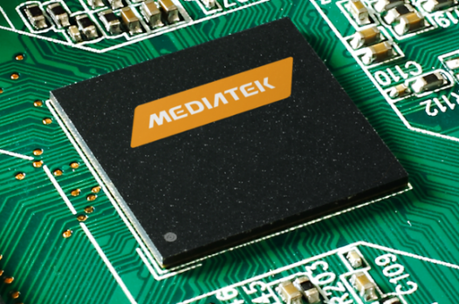 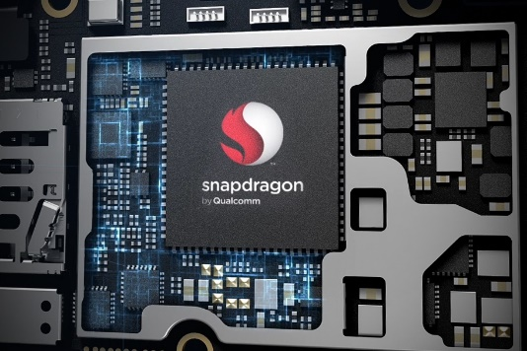

Fig No3: MediaTek Processor Chip FigNo.4: Qualcomm Snapdragon Chip

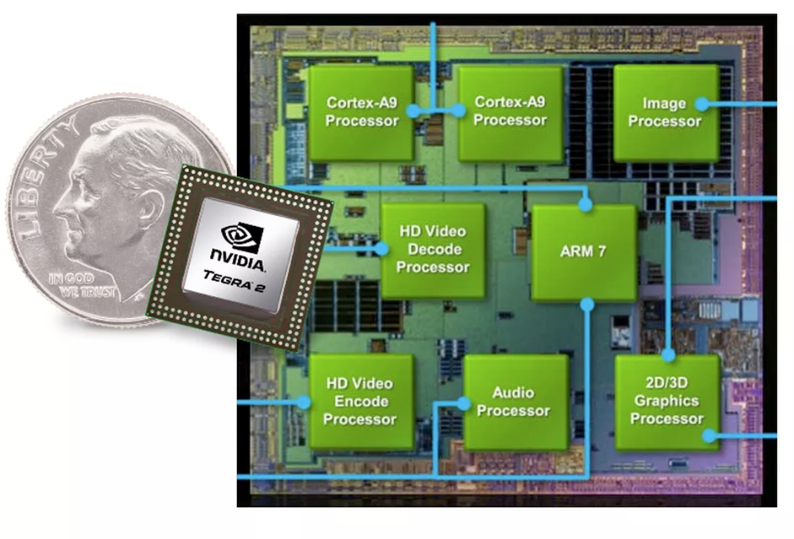

Fig No.:5 Implementation of Graphics Processing Unit

|  |  |  |
| --- | --- | --- |
| CPU | Samsung Galaxy J8 | Lenovo K4 Note |
| CPU Architecture | ARMv7-A | AArch64 Processor rev 4(aarch64) |
| CPU Features | half thumb fastmult vfp edsp neon vfpv3 tls vfpv4 idiva idivt lpae evtstrm aes pmull sha1 sha2 crc32 | fp asimd evtstrm aes pmull sha1 sha2 crc32 |
| CPU Governor | Interactive | Interactive |

Table No. 4: CPU of Devices

|  |  |  |
| --- | --- | --- |
| GPU | Samsung Galaxy J8 | Lenovo K4 Note |
| Renderer | Adreno ™ 506 | Mali-T720 |
| Vendor | Qualcomm | ARM |
| OpenGL Version | OpenGL ES 3.2 | OpenGL ES 3.0 |

Table No. 5: GPU of device

1. **FETCH AND DECODE**

At a high level, fetching a resource is a fairly simple operation. A request goes in, a response comes out. The details of that operation are however quite involved and used to not be written down carefully and differ from one API to the next.

**Fetching the Data in Smartphone:**

[Tasks](https://html.spec.whatwg.org/multipage/webappapis.html#concept-task) that are [queued](https://html.spec.whatwg.org/multipage/webappapis.html#queue-a-task) by this standard are annotated as one of:

* process request body
* process request end-of-body
* process response
* process response end-of-body
* process response done

To queue a fetch task on request to run an operation, run these steps:

1. If request’s [client](https://fetch.spec.whatwg.org/#concept-request-client) is null, terminate these steps.
2. [Queue a task](https://html.spec.whatwg.org/multipage/webappapis.html#queue-a-task) to run an operation on request’s [client](https://fetch.spec.whatwg.org/#concept-request-client)’s [responsible event loop](https://html.spec.whatwg.org/multipage/webappapis.html#responsible-event-loop) using the [networking task source](https://html.spec.whatwg.org/multipage/webappapis.html#networking-task-source).

To queue a fetch-request-done task, given a request, [queue a fetch task](https://fetch.spec.whatwg.org/#queue-a-fetch-task) on request to [process request end-of-body](https://fetch.spec.whatwg.org/#process-request-end-of-body) for request.

To serialize an integer, represent it as a string of the shortest possible decimal number.

**Decode In Android:**

The decoder is a circuit used to change the code into a set of signals.

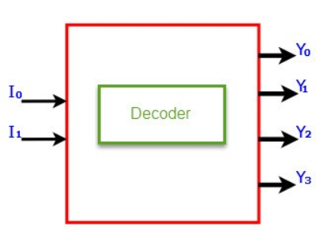

Fig No.6: Decode in Android

# **Base64.Decoder**

This class implements a decoder for decoding byte data using the Base64 encoding scheme as specified in RFC 4648 and RFC 2045.

|  |  |
| --- | --- |
| Public methods | |
| byte[] | [decode](https://developer.android.com/reference/java/util/Base64.Decoder.html#decode(java.lang.String))([String](https://developer.android.com/reference/java/lang/String.html) src)  Decodes a Base64 encoded String into a newly-allocated byte array using the [Base64](https://developer.android.com/reference/java/util/Base64.html) encoding scheme. |
| int | [decode](https://developer.android.com/reference/java/util/Base64.Decoder.html#decode(byte[],%20byte[]))(byte[] src, byte[] dst)  Decodes all bytes from the input byte array using the [Base64](https://developer.android.com/reference/java/util/Base64.html) encoding scheme, writing the results into the given output byte array, starting at offset 0. |
| byte[] | [decode](https://developer.android.com/reference/java/util/Base64.Decoder.html#decode(byte[]))(byte[] src)  Decodes all bytes from the input byte array using the [Base64](https://developer.android.com/reference/java/util/Base64.html) encoding scheme, writing the results into a newly-allocated output byte array. |
| [ByteBuffer](https://developer.android.com/reference/java/nio/ByteBuffer.html) | [decode](https://developer.android.com/reference/java/util/Base64.Decoder.html#decode(java.nio.ByteBuffer))([ByteBuffer](https://developer.android.com/reference/java/nio/ByteBuffer.html) buffer)  Decodes all bytes from the input byte buffer using the [Base64](https://developer.android.com/reference/java/util/Base64.html) encoding scheme, writing the results into a newly-allocated ByteBuffer. |
| [InputStream](https://developer.android.com/reference/java/io/InputStream.html) | [wrap](https://developer.android.com/reference/java/util/Base64.Decoder.html#wrap(java.io.InputStream))([InputStream](https://developer.android.com/reference/java/io/InputStream.html) is)  Returns an input stream for decoding [Base64](https://developer.android.com/reference/java/util/Base64.html) encoded byte stream. |

Table No. 6:Fetch and Decode methods

|  |  |  |
| --- | --- | --- |
| **Fetch and Decode** | **Samsung Galaxy J8** | **Lenovo K4 Note** |
| Fetch | Request trough touch and voice | Request trough touch and voice |
| Decode | Chipset SDM450, msm8953 board | Chipset MT6753 |

Table No. 7:Fetch and decode in device

1. **I/O MECHANISM**

An I/O interface is required whenever the I/O device is driven by a processor. Typically a CPU communicates with devices via a [bus](https://en.wikipedia.org/wiki/Bus_(computing)). The interface must have necessary logic to interpret the device address generated by the processor. Basically, an I/O is used to community with devices.

Input are the task which is provided to the system and the result is displayed on the output device such as screen/monitor. To perform input and output, I/O device can be used. In computing, input/output or I/O is the communication between an information processing system, such as a computer, and the outside world, possibly a human or another information processing system. Inputs are the signals or data received by the system and outputs are the signals or data sent from it. The term can also be used as part of an action to perform I/O is to perform an input or output operation. I/O devices are used by a human (or other system) to communicate with a computer. For instance, a touch screen input device for a smart phone, while screen/displays output device.

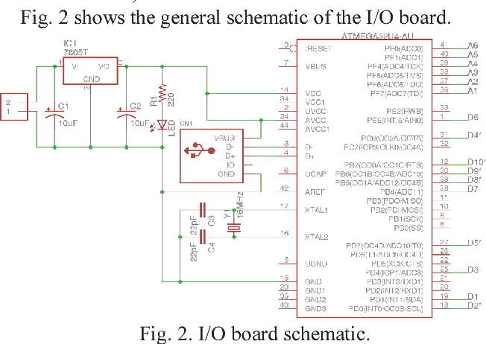

Fig No.7: I/O Board Schematic

To provide a better understanding of input, output, and processing, these concepts are defined as follows.

* **Input** - the information entered into a mobile system, examples include: typed text, touch on screen, etc.
* **Processing** - the process of transforming input information into and output.
* **Output** – the visual, auditory, or tactile perceptions provided by the computer after processing the provided information. Examples include: text, images, sound, or video displayed on a display.
* **Input Device** – any device that enters information into a mobile from a external source. Examples include: touch screens, mouse, trackballs, microphones, etc.
* **Processing Device –**  the electronics that process or transform information provided as an input to a computer/mobile to an output. Examples include: the Central Processing Unit, operating systems, microprocessors (e.g. Mediatek, SnapDragon), memory cards (RAM) and graphic.
* **Output Device** - a device used by a computer to communicate information in a usable form. Examples include: monitors, speakers, etc.

|  |  |  |
| --- | --- | --- |
| Input Methods | Samsung Galaxy J8 | Lenovo K4 Note |
| Action | Touch Screen(6 inch Screen) | Touch Screen(5.5 inch Screen) |
| Keyboard | Digital Keyboard | Digital Keyboard |
| Home Buttons | Digital | Build-in |
| Volume | Volume up and Down Button | Volume up and Down Button |
| Sensor | Smart Sensor(Auto screen off when mobile near to ears while calling) | Smart Sensor(Auto screen off when mobile near to ears while calling) |
| Power | Power Button to switch on/off and restart the device | Power Button to switch on/off and restart the device |
| Fingerprint Sensor | Allow Finger scan to unlock device | Allow Finger scan to unlock device |

Table No. 8:Input I/O Mechanism in Device

|  |  |  |
| --- | --- | --- |
| Output | Samsung Galaxy J8 | Lenovo K4 Note |
| Display | 6 inch Display | 5.5 inch Display |
| LED Light | To told the Notification | To told the Notification |

Table No. 9:Output I/O Mechanism

**8. FEATURES**

|  |  |  |
| --- | --- | --- |
| Feature | Samsung Galaxy J8 | Lenovo K4 Note |
| Display | Touch Screen | Touch Screen |
| Ram | 4GB | 3GB |
| Rom | 64GB | 64GB |
| OS | Android v8.0 (Oreo) | Android v6 (Marshmallow) |
| Processor Speed | 1.6 GHz | 1.3 GHz |
| Processor Type | Octa Core | Octa Core |
| Rear Camera | 16+5MP | 13MP |
| Front Camera | 16MP | 5MP |
| Flash | Flash Light | Flash Light |
| Video Recording | 30fps | 30fps |
| Network | 4G LTE | 4G LTE |
| GPRS | Available | Available |
| WiFi | Available | Available |
| Bluetooth | v4.2 | v4.0 |
| USB | Support | Support |
| GPS | Available | Available |
| Maps | Yes | Yes |
| Battery Capacity | 3500 mAh | 3300 mAh |
| Sim Type | Dual Sim | Dual Sim |
| Finger Print | To unlock mobile | To unlock mobile |

Table No. 10:Features of Samsung J8 and Lenovo K4 note

**9 COMPARISON OF SAMSUNG GALAXY J8 AND LENOVO K4 NOTE**

|  |  |  |
| --- | --- | --- |
| Features | Samsung Galaxy J8 | Lenovo K4 Note |
| Screen Resolution | It have low pixels .(720*1920) | Around 94% more pixels than Samsung Galaxy J8  (1080*1920) |
| Support NFC | It not have a NFC | It have a NFC |
| CPU | It have 38% faster CPU than Lenovo K4 Note.(1.8GHz) | It have slow CPU as compare to Samsung J8(1.3 GHz). |
| RAM | It have 33% more RAM than Lenovo. It means it have more application can run at same time.(4GB) | It have No faster or more RAM.(3GB) |
| Bigger Screen | It have 9% bigger screen than Lenovo K4 Note.(6 inch) | It have small screen as compare to Samsung J8.(5.5 inch) |
| Camera | It has 23% more mega pixels than Lenovo K4 note.so it has more resolution means better picture quality. (16 MP)  It has dual camera | Lenovo K4 Note have less picture quality as compare to Samsung J8.(13 MP).It has single camera. |
| Front camera flash | It have a front camera flash. | It have not a front camera flash. |
| Storage capacity | It have 300% more inbuilt memory than Lenovo K4 note(64 GB) | It have less storage capacity as compare to Samsung J8.(16 GB). |
| Battery | It have 6% more battery capacity then Lenovo K4 note | It have less battery power as compare to Samsung J8 |
| Release Date | May 2018 | January 2016 |

Table No. 11:Different between Samsung J8 and Lenovo K4 note

1. **CONCLUSION**

The mobile phone or smartphone industry are expanding every day which smartphones can help for studies, finding location, gathering information, communicate with others, for entertainment purpose.

The microprocessor company like Qualcomm and mediate can make Smartphone processing more efficient and faster and the concept of Dalvik virtual machine can organize a memory in android devices.

The updating of Smartphone are exploring new world and lots of things to learn, help people to solve their problems and allow them to communicate over a world network.

Smartphone’s allow users to access the web and document information easily. Apps on the phone allow the user to do many things in the palm of their hands. Music, pictures, and files can be carried in a pocket. Along with communicating through basic phone calls, voice mail, and text messages users can send emails directly from their phones. Social networking is made easier with applications and websites always available. Smartphones act as a camera, notepad, calendar, alarm clock, and computer. While smart phones have some security and social issues overall they are devices of great utility that many people find necessary in their daily and professional lives.

**REFERENCES**

* [*https://www.amazon.in/*](https://www.amazon.in/)
* [*https://www.lenovo.com/*](https://www.lenovo.com/)
* [*https://www.samsung.com/*](https://www.samsung.com/)
* [*https://www.qualcomm.com/*](https://www.qualcomm.com/)
* [*https://www.developer.android.com/*](https://www.lenovo.com/)
* [*https://www.en.wikipedia.org/*](https://www.lenovo.com/)